# Cyclistic bike-share analysis

1. **A clear statement of the business task**

The cyclistic data is only available for a month, historic data has not been given to us.   
by going through the data, we can segregate the riders by membership and the type of bike they use.

According to my analysis the count of member and casual as follows:

**Member = 2,85,490**

**Casual = 2,15,418**

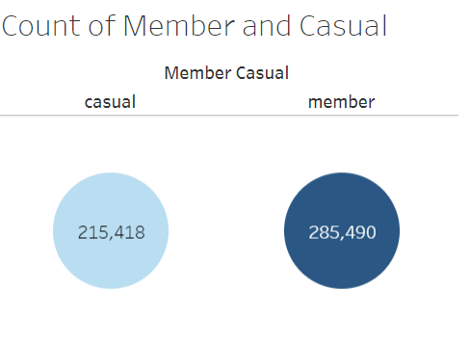

The count of both bikes that has been used by the members are:

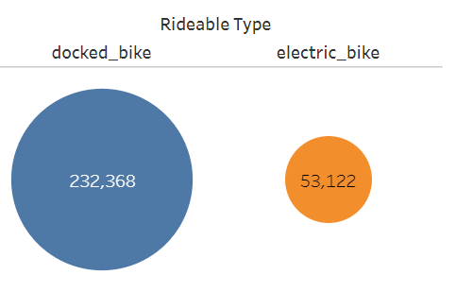

The count of both bikes that has been used by the casuals are:

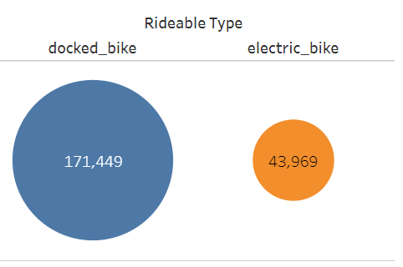

You can understand that both member and casual riders prefer dock bikes more than electric bike.

So, the correct path is to improve the specialisations of dock bike, to achieve more sale in the product and to slightly increase and improve the electric bike model and marketing strategies.

1. **A description of all data sources used**

The data used here gives us a good outline of the riders’ detail, his start time, end time, start station, end station, ride type and membership detail as well.

Using the above data, we analysed the preference of bike, ride, frequency of ride etc.,

1. **Documentation of any cleaning or manipulation of data**

September months data has been provided to us, and I found a lot of null or blank values, using excel function sorted it out and started my analysis.

1. **A summary of your analysis**

Both members and casual people largely use bike, almost 57% of members and 43% of casual riders use the bike.

We can potentially bring the casual riders to be a member, as they all are equally interested

The summary:

* Members primarily use the bikeshare for commuting and tasks, while casuals use it on weekends for long ride and recreation.
* Casual riders should be identified and offered with cycle weather period membership to increase the number.
* Marketing platforms like Instagram, Facebook etc., with help of influencers, we can bring the awareness of health benefits from cycling.

1. **Supporting visualizations and key findings**

Tableau Dashboard

1. **Your top three recommendations based on your analysis**

- Seasonal offer price membership only for good weather season, can increase the number of casual riders during summer month.

- Using local influencers on social media platform such as YouTube, snapchat, Instagram promote the bikeshare and show its appeal to residents.

- More data is required to understand the residence of casual riders to customise the marketing plan.

- Should promote electric bike use, benefits and safety, as they may be the area of growth for cyclistic.